# Testing Lab 3: More Component Testing

## Objectives

 Test Setup

 Testing a Prop

 Testing a Function Prop

 Taking a Snapshot

## Steps

### Test Setup

1. **Create** the **directory** src\projects\__tests__.
2. **Create** the **file** src\projects\__tests__\ProjectCard-test.js.
3. **Add** the **setup** code below to test the component.

#### src\projects\__tests__\ProjectCard-test.js

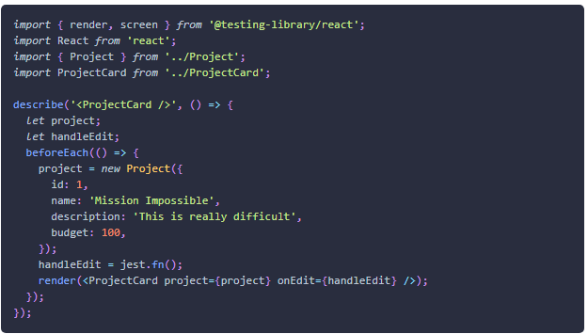

1. Verify the test fails.

FAIL src/projects/__tests__/ProjectCard-test.js

Invariant failed: You should not use <Link> outside a <Router>

1. Wrap the component in a MemoryRouter.

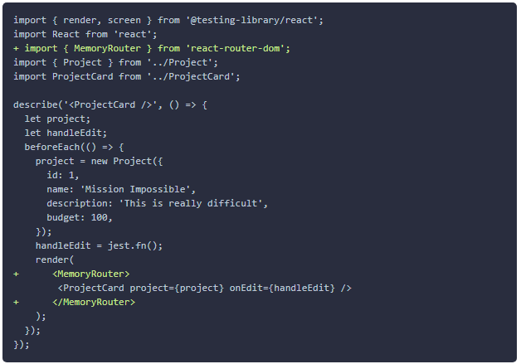

<MemoryRouter> - a <Router> that keeps the history of your "URL" in memory (does not read or write to the address bar). Useful in tests and non-browser environments like React Native.

1. Verify the initial test now passes.

PASS src/projects/__tests__/ProjectCard-test.js

### Testing a Prop

1. Open a command-prompt or terminal and run the following command to install user-event from the core testing library behind React testing library.

npm install --save-dev @testing-library/user-event @testing-library/dom

1. **Test** that the project **property renders correctly**.

#### src\projects\__tests__\ProjectCard-test.js

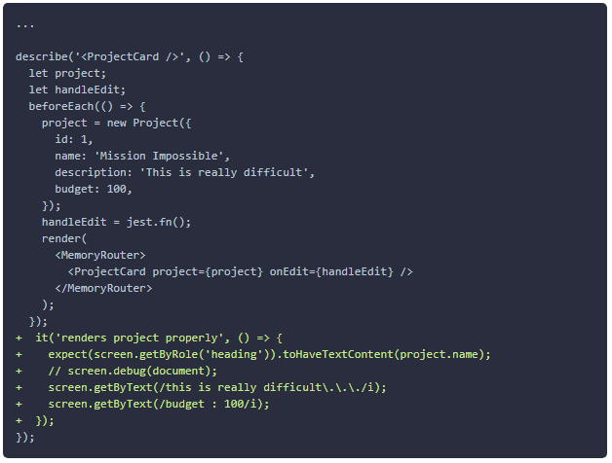

1. **Verify** the **test passes**.

PASS src/projects/__tests__/ProjectCard-test.js

### Testing a Function Prop

1. Open a command-prompt or terminal and run the following command to install user-event from the core testing library behind React testing library.

npm install --save-dev @testing-library/user-event @testing-library/dom

1. **Test** that the **handler prop** is called when edit is clicked.

#### src\projects\__tests__\ProjectCard-test.js

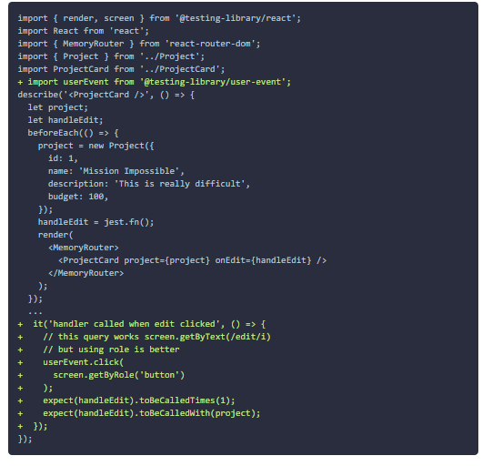

1. **Verify** the **test passes**.

PASS src/projects/__tests__/ProjectCard-test.js

### Taking a Snapshot

1. **Take** a **snapshot** of the component.

#### src\projects\__tests__\ProjectCard-test.js

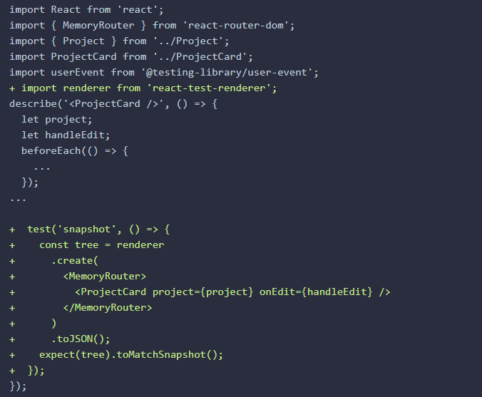

1. **Verify** the **snapshot** is taken.

✓ 1 snapshot written

### ✔ You have completed Testing Lab 3